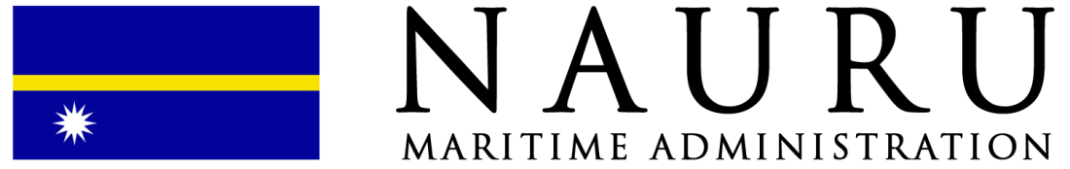

Application for Exemption from or Extension of an International Convention Requirement
(FORM NMA-18_EXT.2018.Rev.0)

INSTRUCTIONS:
- This form is to be completed (in the applicable sections) by the company and recognised organization (RO) and submitted for review and approval.
- If necessary, each application can be supported by the appropriate documention, calculation and technical justification in respect to the exemption / extension being applied for. Additional sheets may be attached to this application if there is insufficient space on the form.
- Exemptions can only be issued when there is provision within the appropriate convention or regulation.
- Fees may be applicable for each approved application for exemption.
1. VESSEL PARTICULARS
Vessel Name / Hull Number (for new build) | IMO Number (if applicable) |  | Type of Vessel
Keel Laid Date | Gross Tonnage |  | Load Line Length - (article 2(8))
Classification Society / RO | Registered Owner
2. APPLICATION FOR EXEMPTION CERTIFICATE
Apply to be exempted from the requirements of: |  | Conferred by the Regulations of:
Reason(s) supporting the application:

Duration of exemption requested:

Safety Measure(s) taken:

Recognized Organization (Classification Society) recommendations related to this application:

3. APPLICATION FOR EXTENSION FOR DOCKING / SPECIAL SURVEY OR STATUTORY CERTIFICATES
Type of certificate(s) to be extended

Reason(s) supporting the application:

Duration of extension requested:

Safety Measure(s) taken:

Recognized Organization (Classification Society) recommendations related to this application:

4. DECLARATION BY OPERATOR / CHARTERER / OWNER OF VESSEL
I / We, the undersigned, hereby declare that the above mentioned vessel has not been subject to any accident or other occurrence which would cause any doubt on the vessel’s seaworthy and that the vessel is properly equipped to operate within the limits prescribed in the certificates.

Date: | Signature and Stamp of authorized person:

Unit C, 20/F, Eton Building, 288 Des Voeux Road Central, Sheung Wan, Hong Kong.
Website: www.naurumaritime.com Email: flag@naurumaritime.com
Tel: 852-36223737 Fax: 852-36223210

